|  |  |
| --- | --- |
|  | FPT ACADEMY INTERNATIONAL  FPT – APTECH COMPUTER EDUCATION |

Centre Name: ACE-HCMC-2-FPT.

Address: 590 Cach Mang Thang 8, District 3, Ho Chi Minh City, Viet Nam.

**THE DESTINATION**

|  |  |  |
| --- | --- | --- |
| Supervisor: | Phạm Thị Lánh | |
| Term: | 1 | |
| Batch No: | T1.2208.M0 | |
| Group No: | 6 | |
| Order: | Full name | Roll No. |
| 1. | Đồng Đại Dương | Student1405200 |
| 2. | Trần Ngô Tấn Thịnh | Student1405191 |
| 3. | Nguyễn Vũ Cao Sơn | Student14052189 |
| 4. | Phạm Trần Lê Minh | Student1405184 |

Month 11 Year 2022

This is to certify that

**Mr. Đồng Đại Dương**

**Mr. Trần Ngô Tấn Thịnh**

**Mr. Nguyễn Vũ Cao Sơn**

**Mr. Phạm Trần Lê Minh**

Have successfully Designed & Developed

**THE DESTINATION**

Submitted by: **Ms. PHAM THI LANH**

Date Of Issue: November, 2022

Authorized Signature:

# Content

Acknowledge 5

Synopsis 6

REVIEW 1 7

Problem Definition 8

Customer Requirements Specifications 9

Site map 10

Screen shots 11

1. Homepage 11

2. Galary 12

3. Information page 13

4. Club page 14

Task Sheet 15

REVIEW 2 16

I. WEBSITE USER INTERFACE 17

1. Home Page 17

2. Galery 18

3. Organization 23

4. Information 24

5. About us 28

II. MOBILE WEBSITE USER INTERFACE 30

1. Home Page 30

2. Galery 31

3. Organization 33

4. Information 34

5. About us 37

Task Sheet 38

Testing Document 39

# Acknowledge

As we understand that the eProject is a step-by-step learning environment that closely simulates the classroom and Lab based learning environment into actual implementation. It is a project implementation at your fingertips!! An electronic, live juncture on the machine that allows you to.

✓ Practice step by step i.e., laddered approach.

✓ Build a larger, more robust application.

✓ Usage of certain utilities in applications designed by the user.

✓ Single program to unified code leading to a complete application.

✓ Learn implementation of concepts in a phased manner.

✓ Enhance skills and add value.

✓ Work on real life projects.

✓ Give a real-life scenario and help to create applications more complicated and useful.

✓ Mentoring through email support.

We would like to express our sincere gratitude to our lecturer and the other students for their wonderful assistance during the project.Beside several mistakes we had made in the project, we hope to have more opportunities to widen our knowledge in the web developing world.

We also thank you so much for your information and the “demo” project from India APTECH to help us get more reality experience in this project. Since we have gained more experience from this project, we will not stop learning anything as much as we can to be more successful in the future.

Your Sincerely,

Team Group 06.

# Synopsis

- The Objective of this program we aim is to give a sample project to work on real life projects. These applications help us build a larger, more robust application.

- The objective is not to teach us HTML/JavaScript but to provide us with a real life scenario and help us create basic applications using the tools.

- Hence, we can revise the chapters before we start with the project.

- This project The Objective of this program is to give a sample project to work on real life projects. These applications help you build a larger, more robust application.

- The objective is not to teach you the software but to provide you with a real-life scenario and help you create basic applications using the tools.

- You can revise the topics before you start with the project.

- This project is meant for students who have completed the module of HTML5.

- These programs should be done in the Lab sessions with assistance of the faculty if required.

- The website (in this project) is a tool that help the company to access the

international market and gain more and more new customers.

- It is very essential that a student has a clear understanding of the subject.

# 

# REVIEW 1

## Problem Definition

The Destination is a website that will give detailed information about mountaineering. Unlike most sports, mountaineering lacks widely-applied formal rules, regulations, and governance to a large variety of techniques and philosophies when climbing mountains.

The website is to be developed for the Windows Platform using HTML5, JavaScript and Geolocation. The site should work well in all leading browsers including Chrome, IE, Firefox etc.

There are some problems which need to be resolved:

1. The website which they demand is supposed to provide users with a friendly environment and navigation. The important menu must be stated in the top section of the webpage. Also, a decent lookout and color combination are expected.
2. For the untrained, mountaineering is a dangerous pastime. Therefore, they need a website that provide the introduction of Hazards, Technique and mountaineering style for them and a certain amount of previous experience will be found necessary.
3. After customer choosed one of mountains for their climbing, our site need to provide a Tour page including many Travel tour to this mountain for them to regist.
4. Existing customers needing some help and support on the product after installation would have to contact The Destination office through a phone number or email address.

## Customer Requirements Specifications

|  |
| --- |
| USER: |
| Input:  ● Input customers’s name, email, phone, country, and subject.  ● Send requests to the company |
| Process:  ● Process customers’s address data  ● Collect requests sent by customers |
| Output:  ● Show the Thank You board for customers  ● Reply to the consumer’s requests |

|  |
| --- |
| WEBMASTER: |
| Input:  ● Control website database, interact with information on website, etc. |
| Process:  ● Analyse website |
| Output:  ● Website interface, images, forms, videos, etc.  ● Giving interaction |

|  |
| --- |
| HARDWARE / SOFTWARE REQUIREMENT: |
| Software:  ● Notepad/HTML editor  ● Dreamweaver/Javascript |
| Hardware:  ● A minimum computer system that will help you access all the tools in the courses is a Pentium 166 or better  ● 64 Megabytes of RAM or better |

## Site map

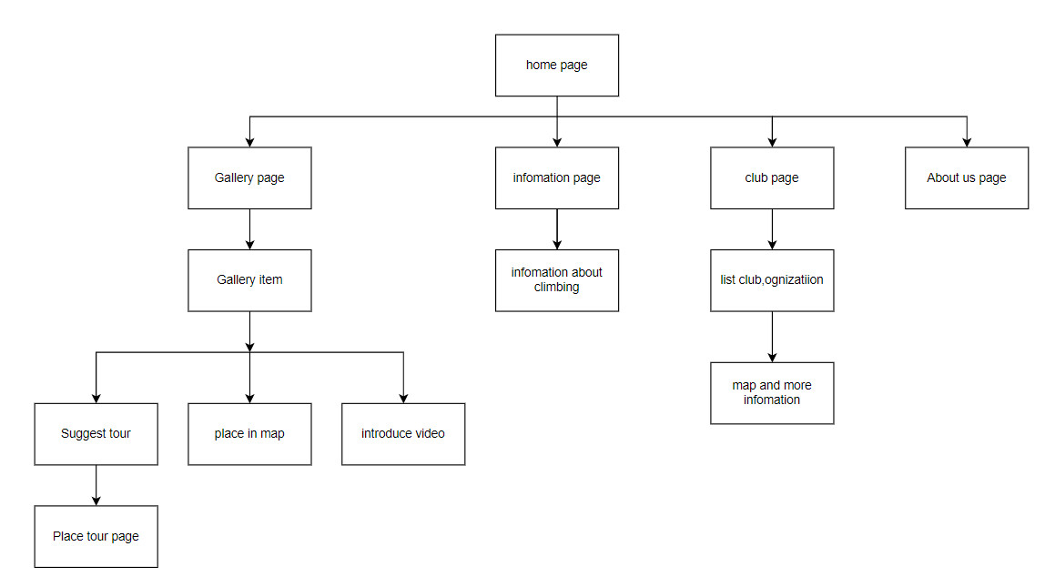

## Screen shots

### 1. Homepage

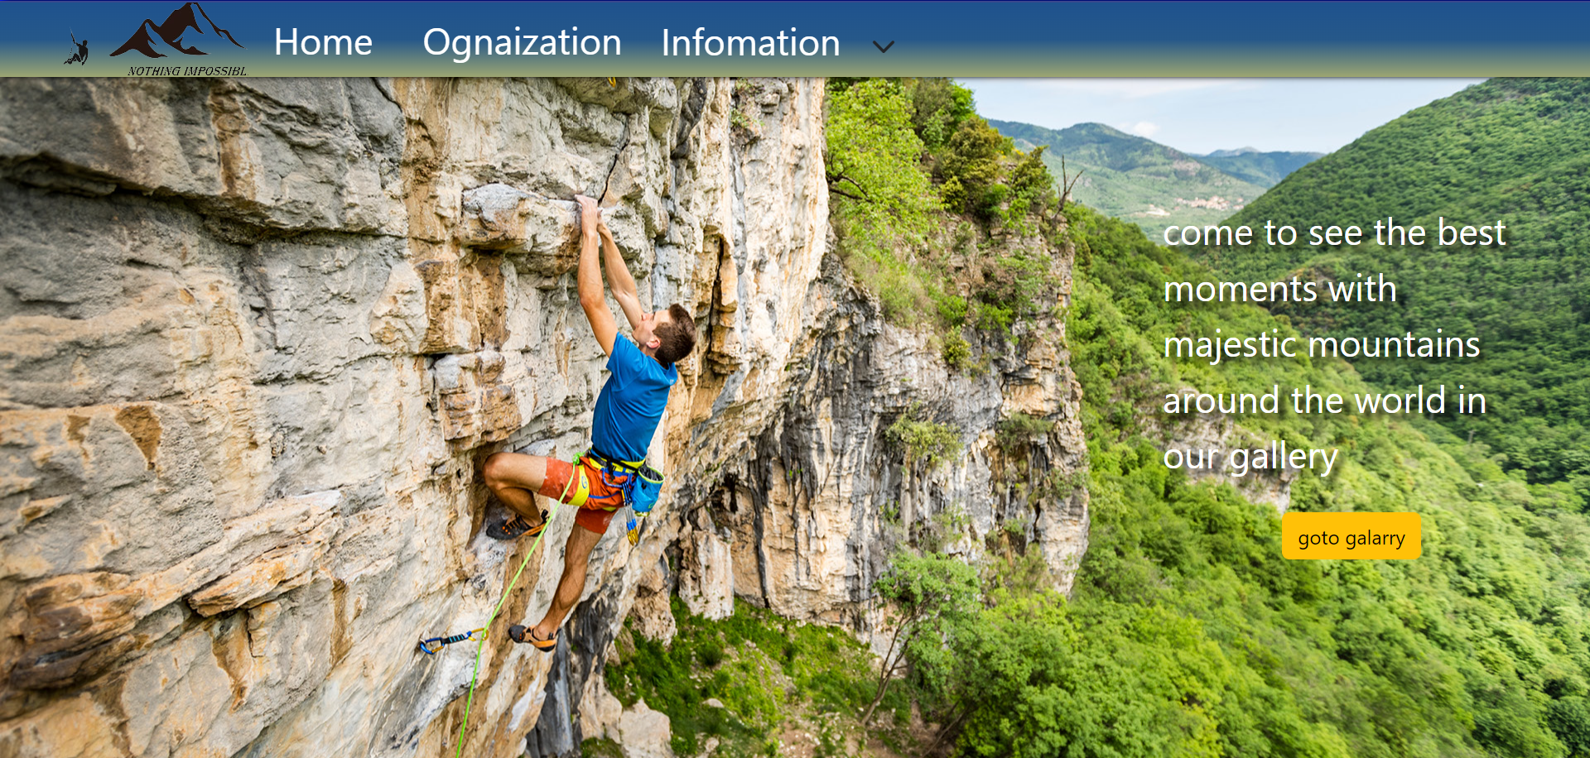

**Description:** This is a homepage of The Destination, the top of this page is a header, after that is a navigation bar including 4 sections: home, Organization ,Information and goto Galary.

### 2. Galary

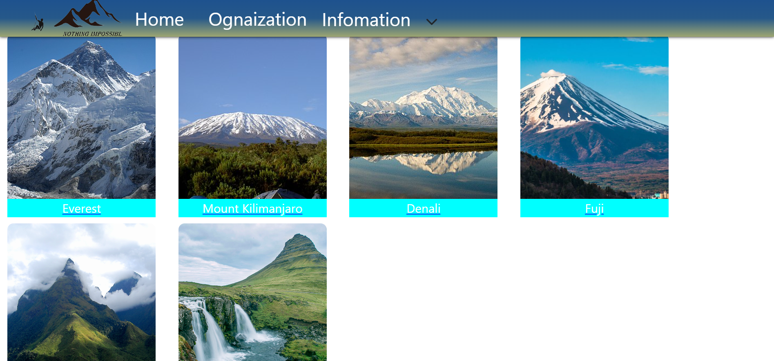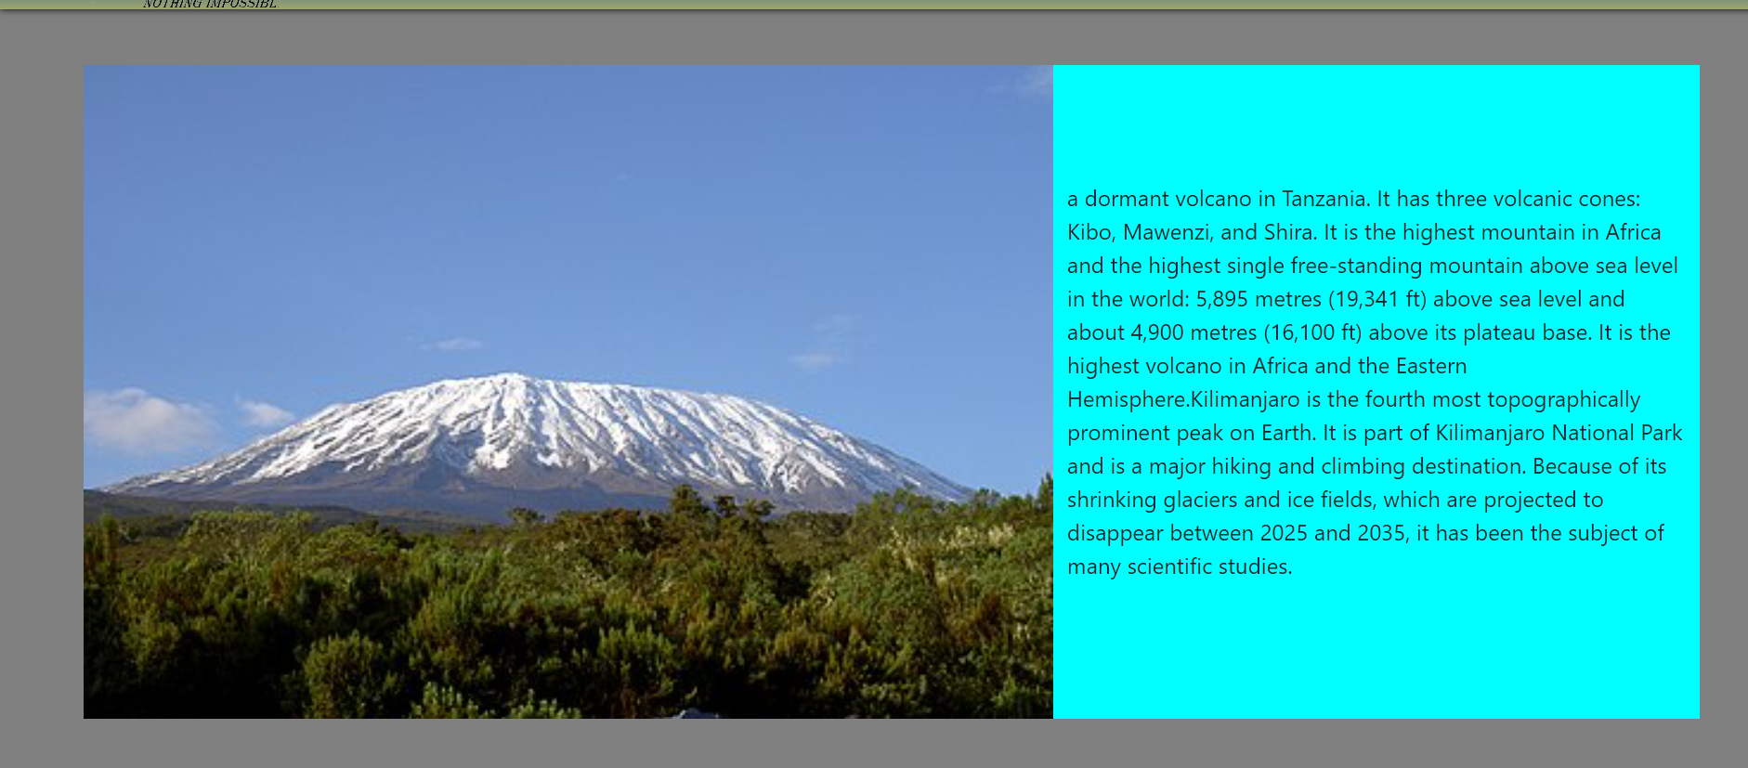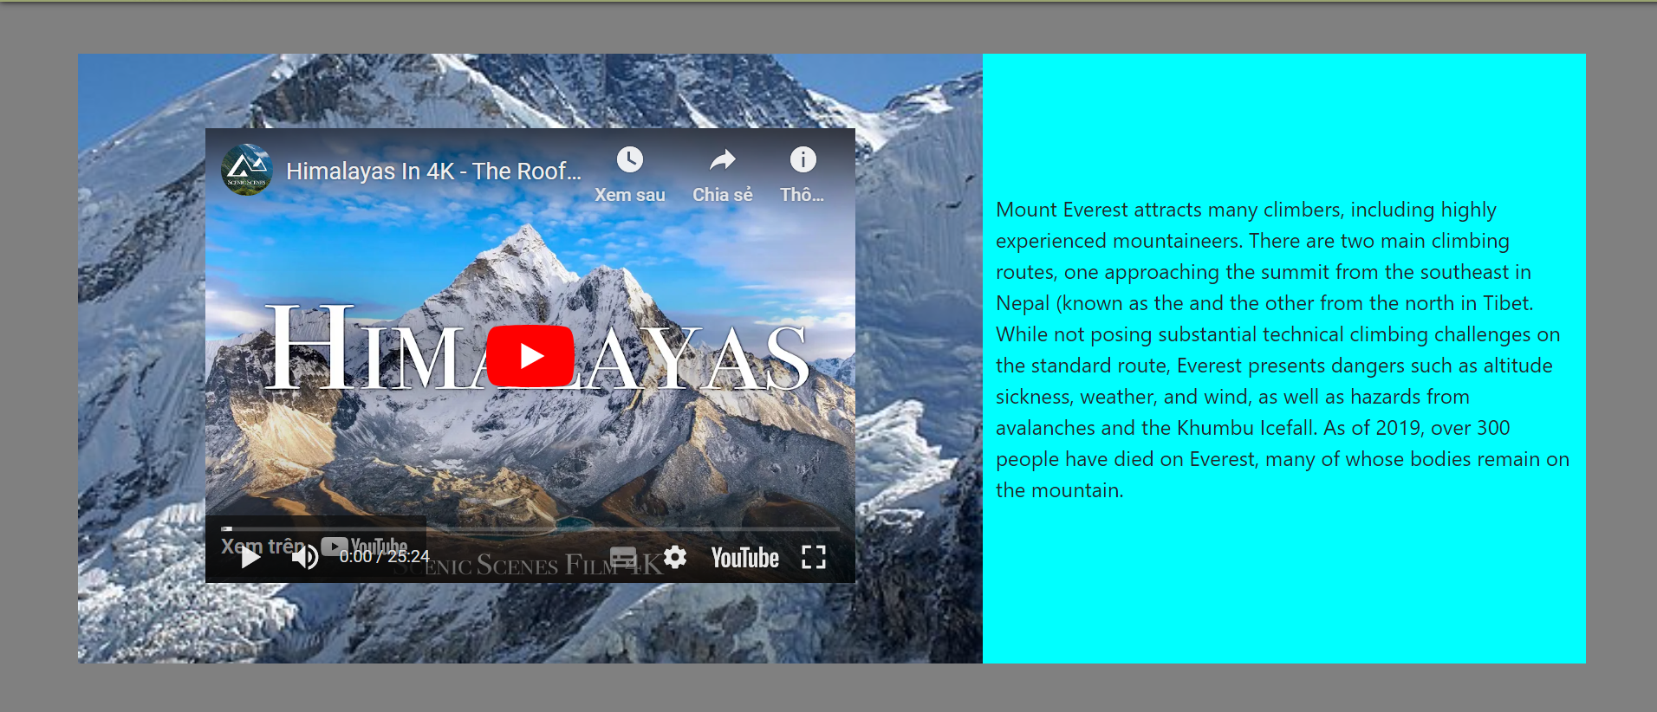

**Description:** this page will show famous mountain in the world .each item will include info mation , picture and more info mation after click.

### 3. Information page

**Description**.it will include infomations is required (history, style shelter,hazzad..)

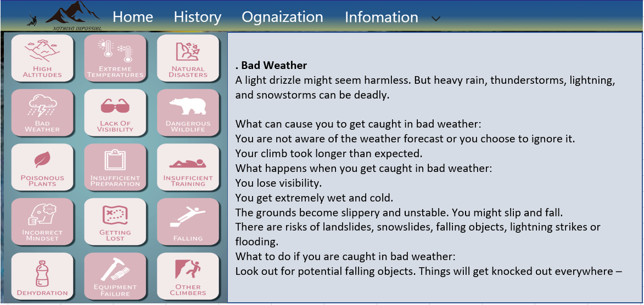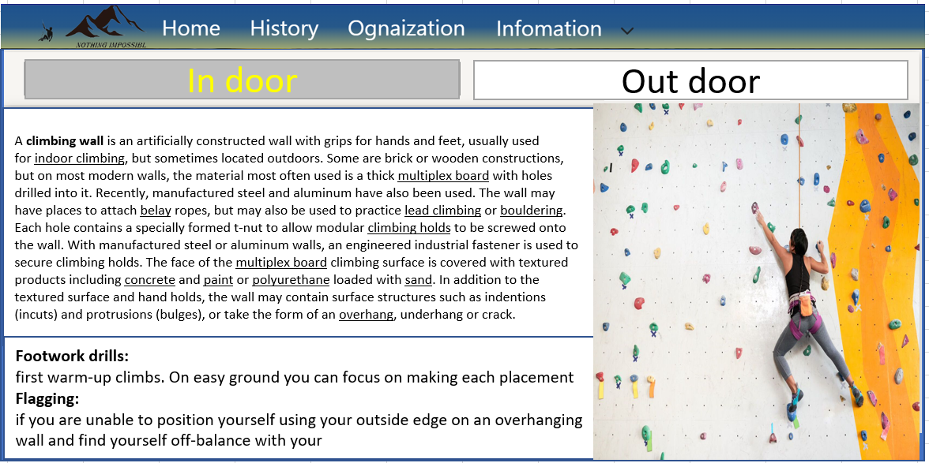

### 4. Club page

**Description:** Page show some club or ognization relative ro climbing or mountaineering. After click have modal show more information , location in map and link to their webpage.

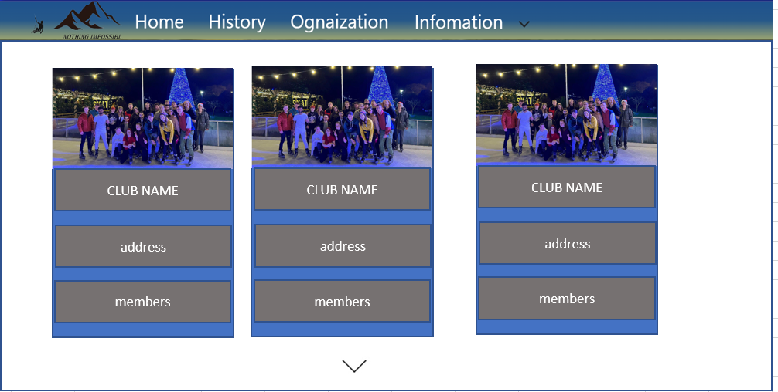

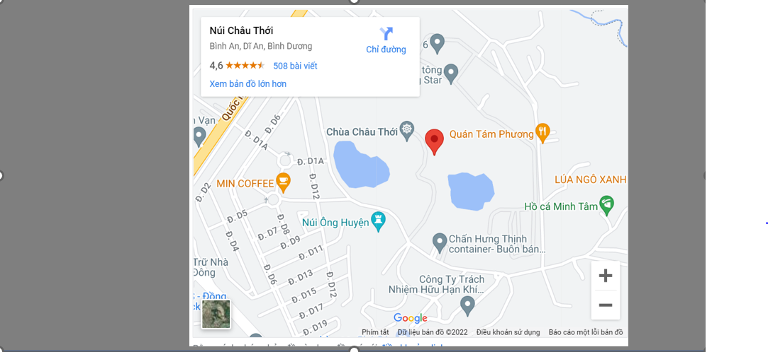

## Task Sheet

|  |  |  |  |  |
| --- | --- | --- | --- | --- |
| **TASK** | **Activity Plan Prepared by** | **Date of preparation of Activity Plan** | | |
| **Actual Start Date** | **Actual Days** | **Status** |
| Brainstorming ideas for layouts and Project Object | Dương, Minh, Thịnh,Sơn | 24/10/2022 | 3 days | 100% |
| Draw site maps and architecture design | Dương, Minh, Thịnh,Sơn | 27/10/2022 | 2 days | 100% |
| Wireframing general page layout | Dương, Minh, Thịnh,Sơn | 29/10/2022 | 2 days | 100% |
| Collect static assets (pictures, video, documentation,…) | Dương, Minh, Thịnh,Sơn | 31/10/2022 | 2 days | 100% |

# 

# REVIEW 2

# I. WEBSITE USER INTERFACE

### 1. Home Page

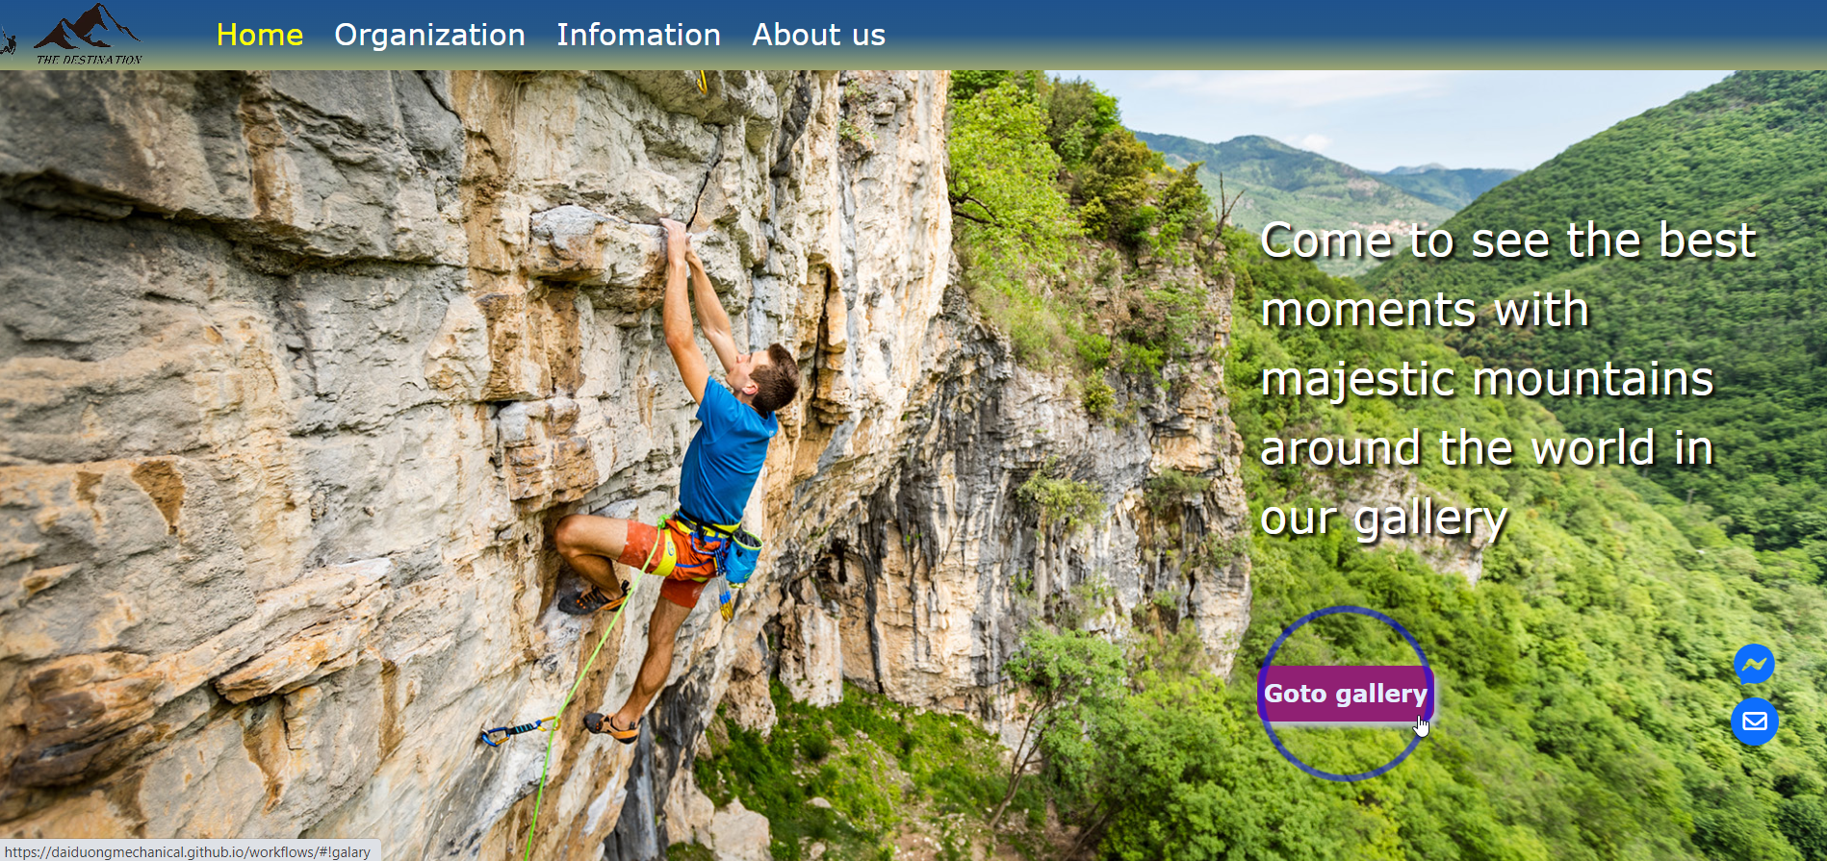

*Image 2.1: Home Page*

**Description:** The header of the Home page shows a navigation bar including 4 sections linked to 4 sub information pages: Home, Organization, Information, About Us. In the Home page background, it includes the “go to Galary background” button which used to move to Galary page.

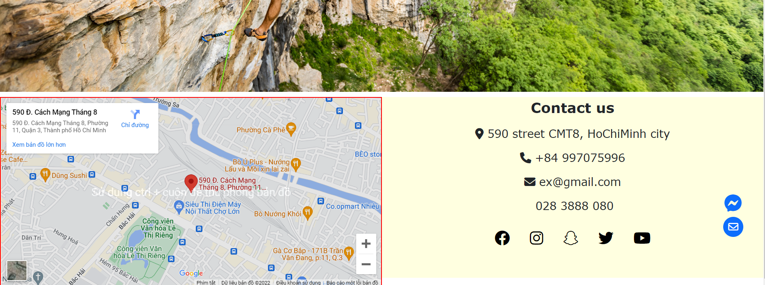

*Image 2.2: Footer*

**Description:** The left information of the footer shows location of Group 6 Workplace. The right side of footer include some information for contacting such as: address, phone, email, youtube channel, twitter, etc.

### 2. Galery

When user clicks to “Go to Galery” button, Home page will be moved to Galery page.

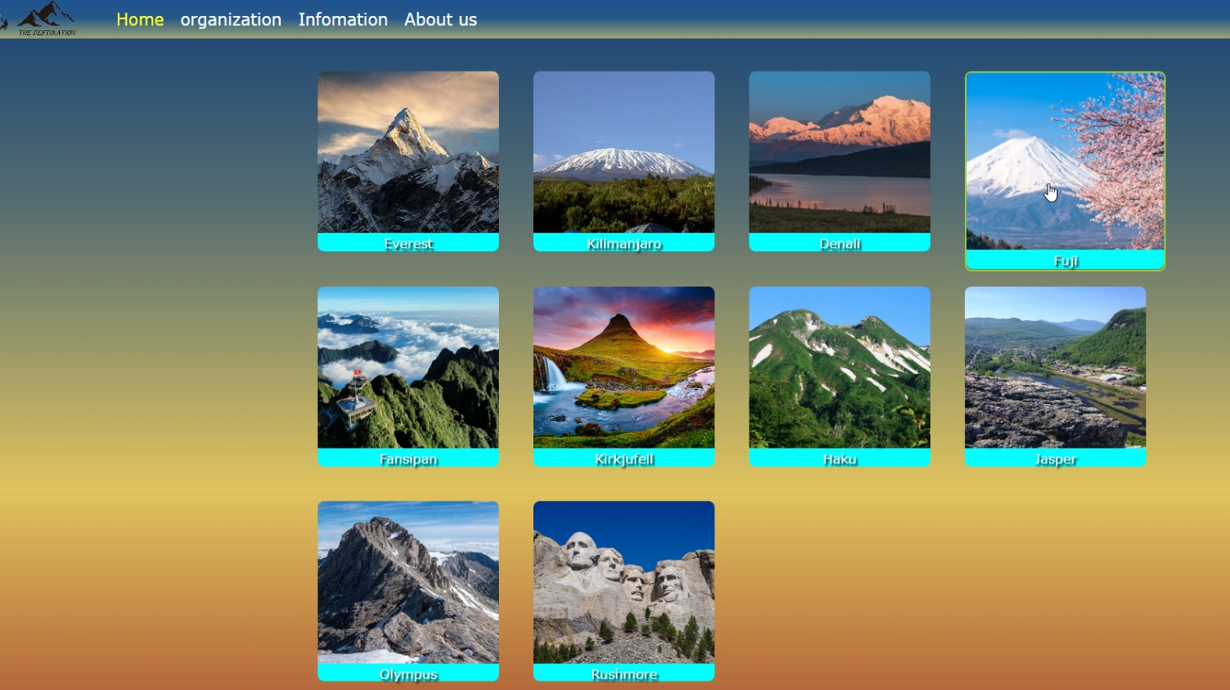

*Image 2.3: Galary page*

**Description:** Galery page contain 10 sections showing the names and images of mountains. There are 10 mountains including: Everest, Kilimanjaro, Denali, Fuji, Fansipan, Kirkjufell, Haku, Jasper, Olympus, Rushmore.

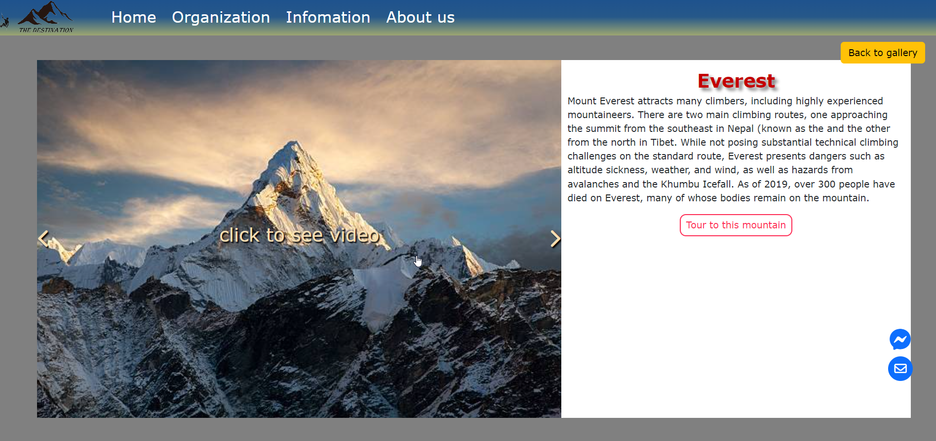

*Image 2.4: Detail information of mountain in Galery*

**Description:** When user click to every mountain image, it will move to the new page which describe the name, information, and 3 images of each mountain. User can use the “<” and “>” button to see other mountain images. User can use the “Back to Galery” button to move back to Galery Page.

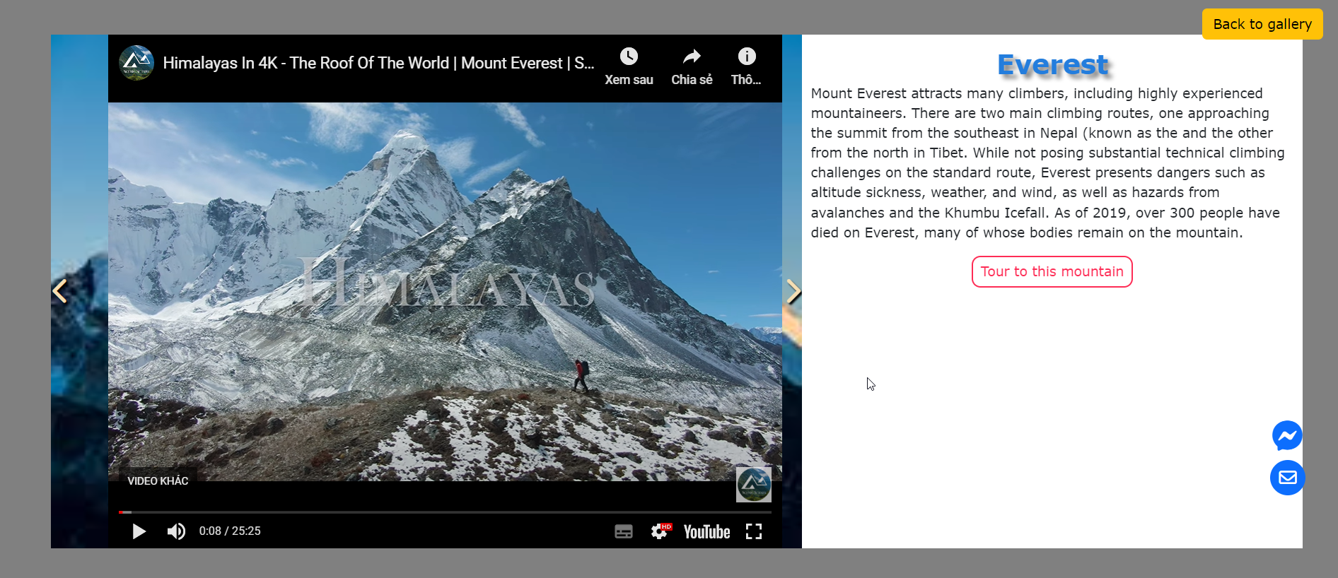

*Image 2.5: Galery video*

**Description:** If user click to “click to see video” section, it will show the video of the moutain. Further more, if you want to travel to one of these moutains, you can click to “Tour to this mountain” button to move to Tour Page.

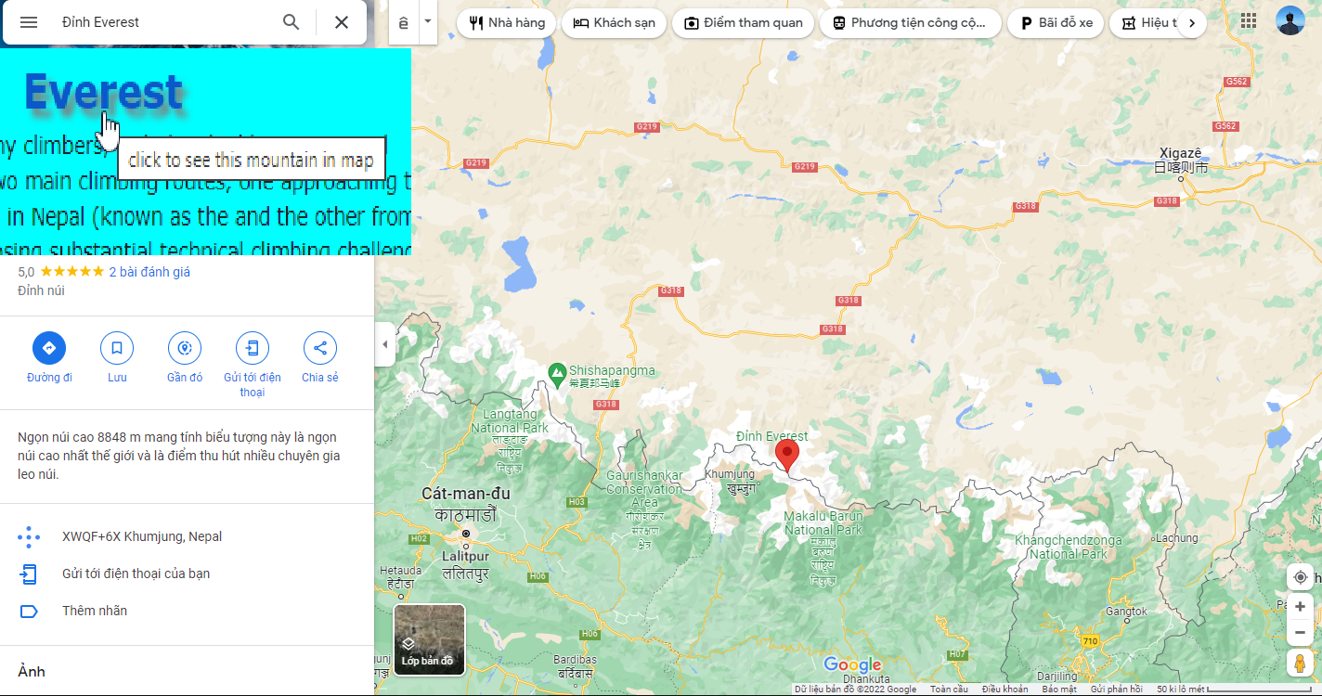

*Image 2.6: Mountain location*

**Description:** Click to the name of the mountain, web page will be moved to the Google Map page to show the location of this mountain.

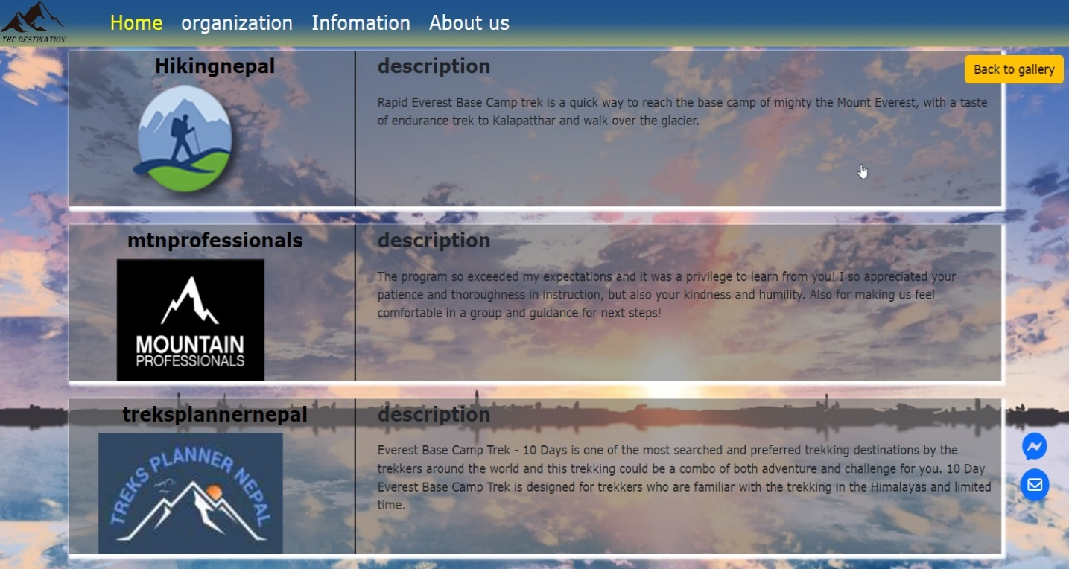

*Image 2.7: Tour page*

**Description:** When user click to the Tour Page of Everest mountain, there are Tour suggest pages.

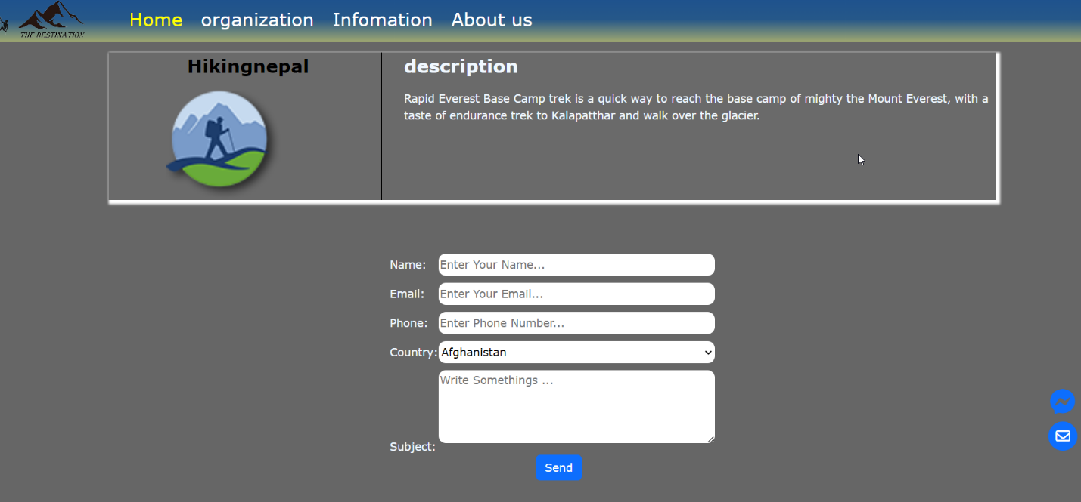

*Image 2.8: Tour Registration*

**Description:** If user chooses one of these Tours, website will be moved to a booking page. At here, we have to provide some informations for registering tour.

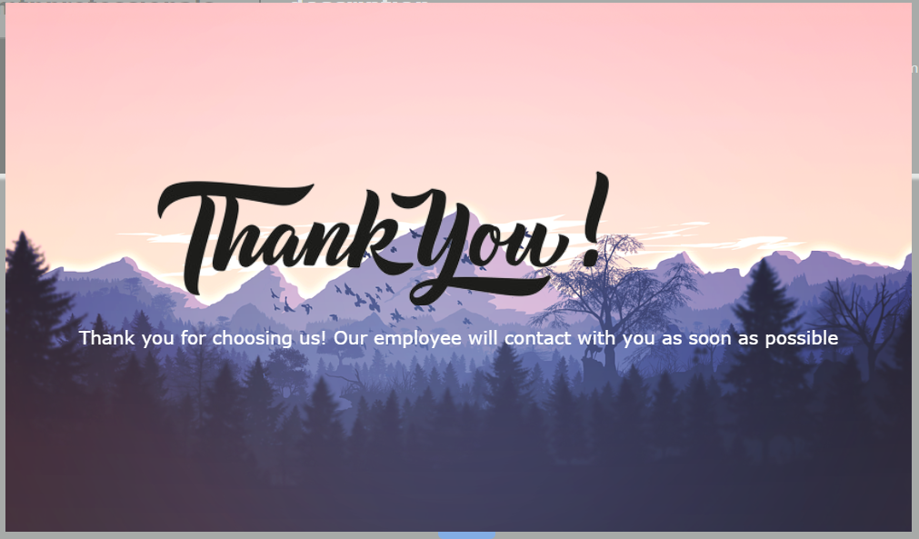

*Image 2.9: Thank you*

**Description:** After finishing the form validation, our website will show the board to thank user for choosing us.

### 3. Organization

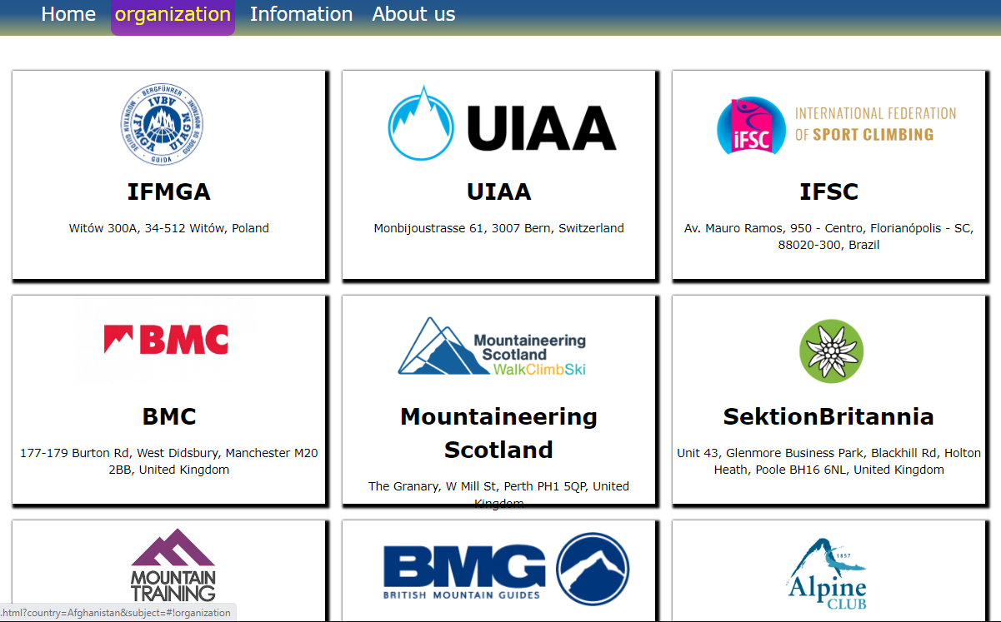

*Image 2.10: Organization page*

**Description:** Moving to the second section on the Nav bar, the information of Mountaineering Organization in the world will be showed on this page.

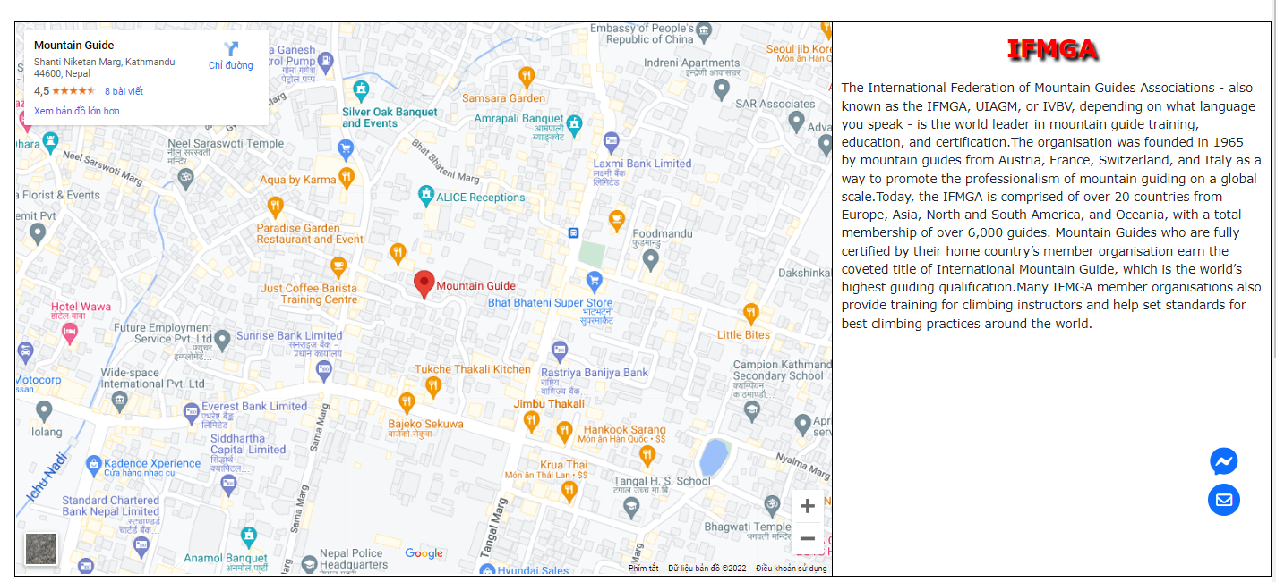

*Image 2.11: Details of organization*

**Description:** When user click to one of the organizations, our Web will show the information and location of organization. If you want to know the information in more detail, you can click to the name of the organization. The name is linked to the website of this mountaineering organization.

### 4. Information

There are 5 sections including History, Hazard, Style, Shelter and Skill in the Information page. We also have a hide and show button containing 5 sections and we can move to each sections when we click to the tittle of the section.

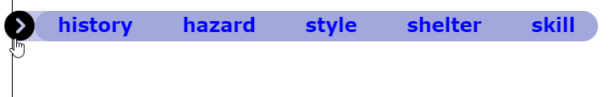

*Image 2.12: 5 sections of Information page*

*Image 2.13: History section*

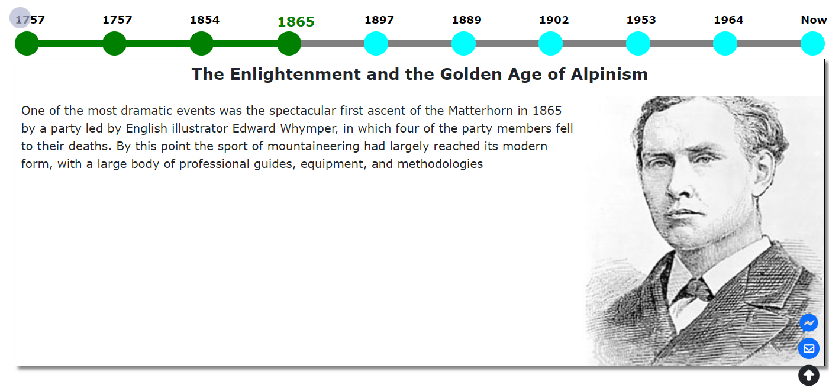

**Description:** History section will show the history of mountaineering and famous climber with the timeline from 1757 to the present. User can read different information by clicking on the button below the year, the color will be change from the first year to the year that user click on.

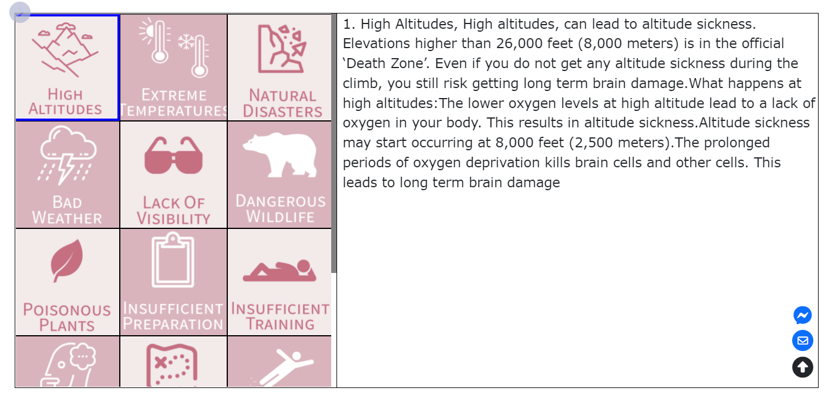

*Image 2.14: Hazard section*

**Description:** The number one danger of mountain climbing is the lack of awareness. Mountain climbing has its inherent environmental dangers. Therefore, we provide the list of 15 potential dangers that you would face on the mountains. Each icon provides the information of danger belonged to it.

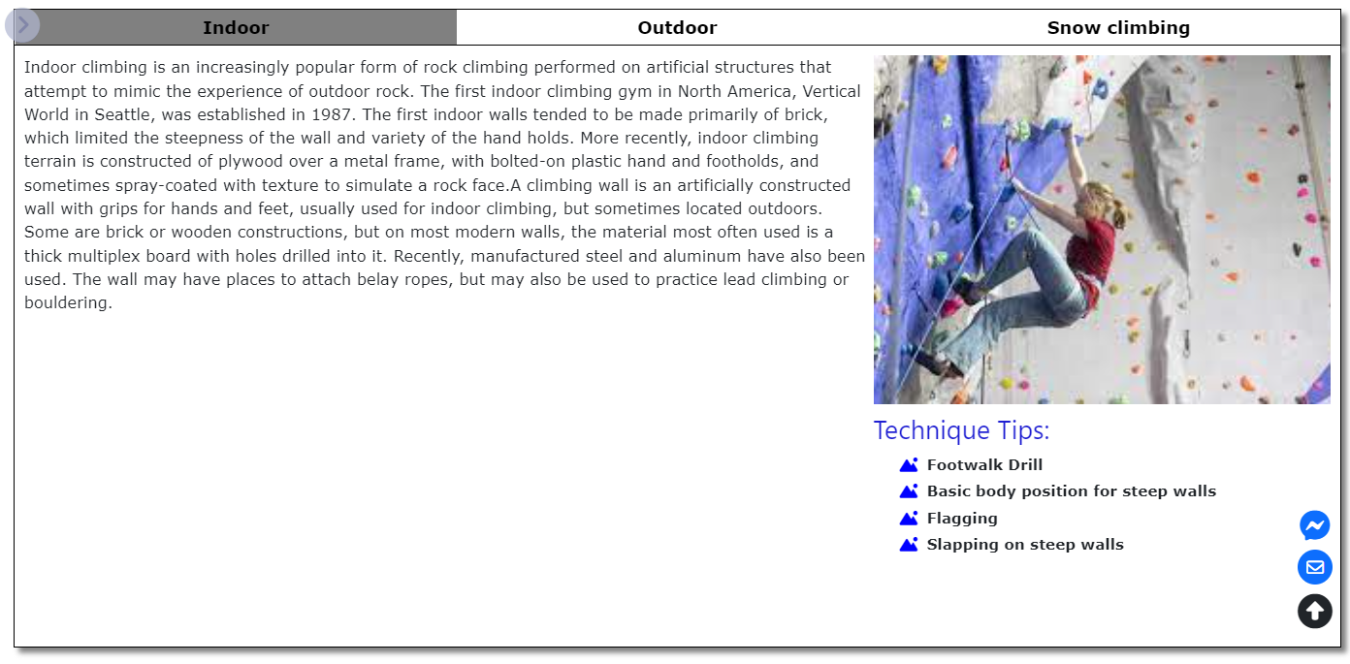

*Image 2.15: Style section*

**Description:** The Style section contain 3 different style of mountaineering: Indoor, Outdoor, and Snow Climbing. User can click to each tittle to gain more knowledge of mountaineering style and each style contain 3 automatic change image.

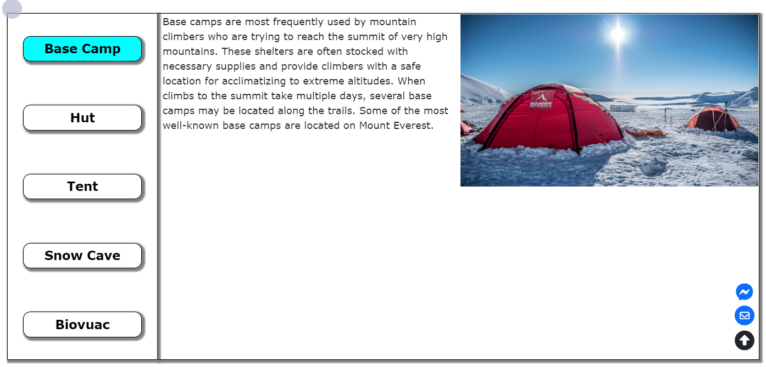

*Image 2.16: Shelter section*

**Description:** The shelter section shows general information of Base Camp, Hut, Tent, Snow Cave and Biovuac.

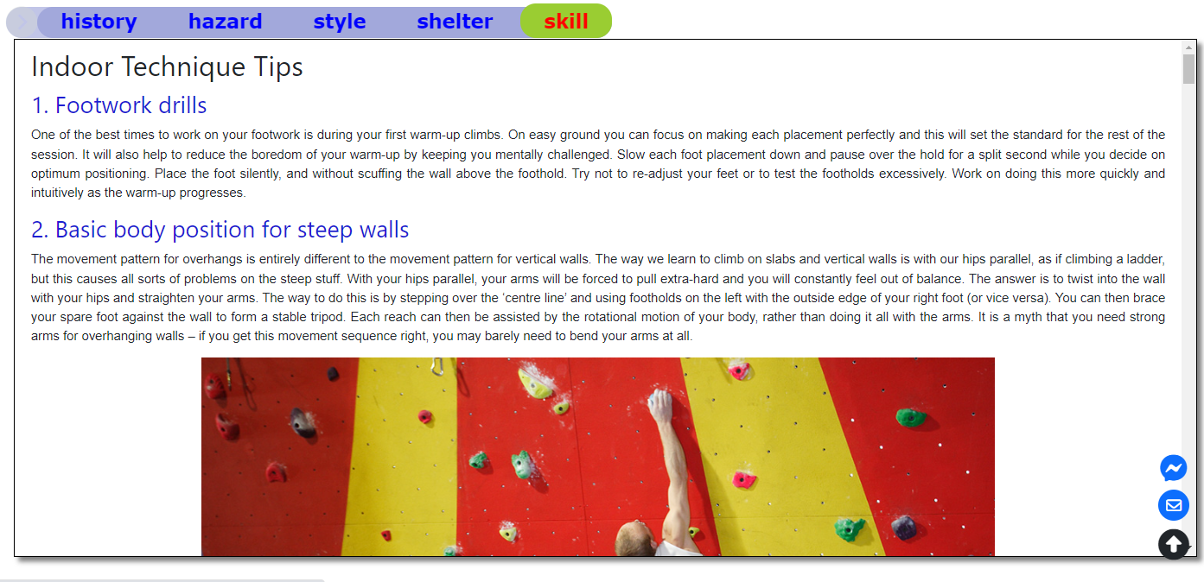

*Image 2.17: Skill section*

**Description:** The last section is Skill which show the Technique Tips for 3 styles of mountaineering in more detail, it also includes image and video to guide for climber.



*Image 2.18: Return Button*

**Description:** Moreover, our Web page also have a arrow button which will lead user to move to the first section of Information Page.

### 5. About us

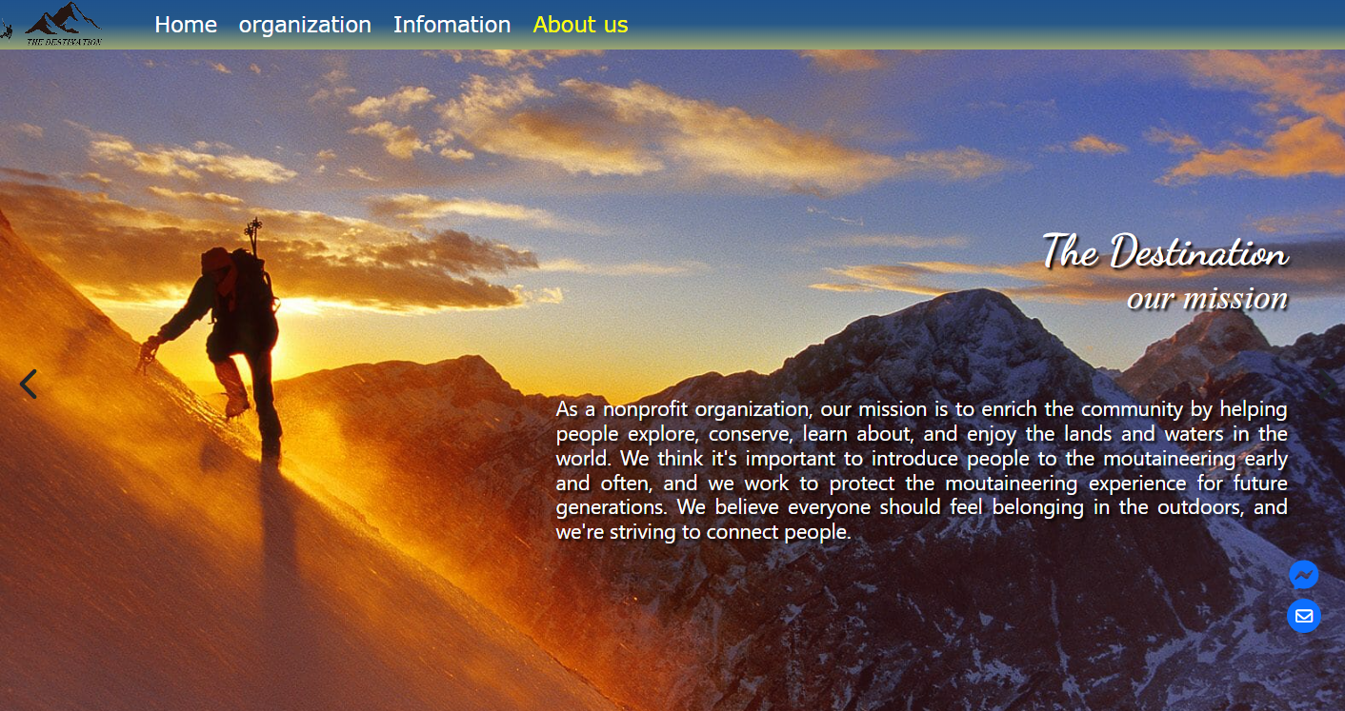

*Image 2.19: About us page*

**Description:** The final section on Nav bar is About The Destination team, user can click to “<” and “>” Button to switch slide get more information about us.

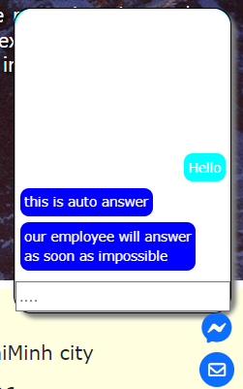

*Image 2.20: Chat box*

**Description:** Further more, we also provide a button for user that they can give direct message or send email to our Web page.

# II. MOBILE WEBSITE USER INTERFACE

### 1. Home Page

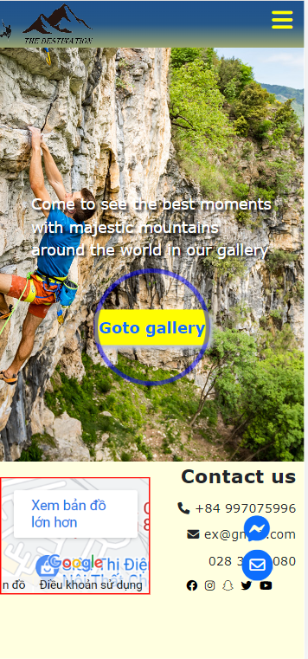

### 2. Galery

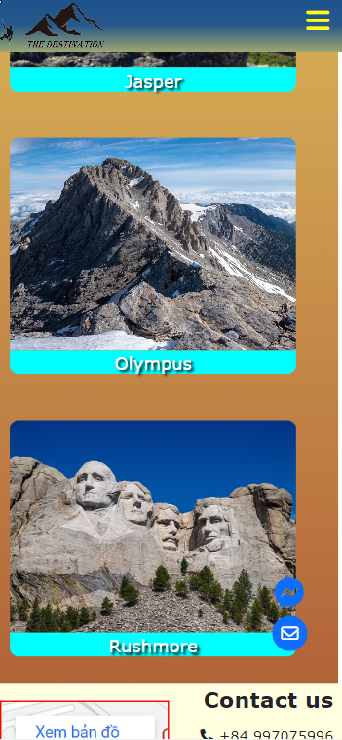 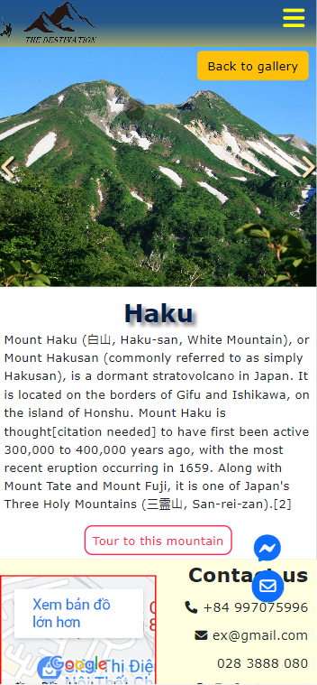

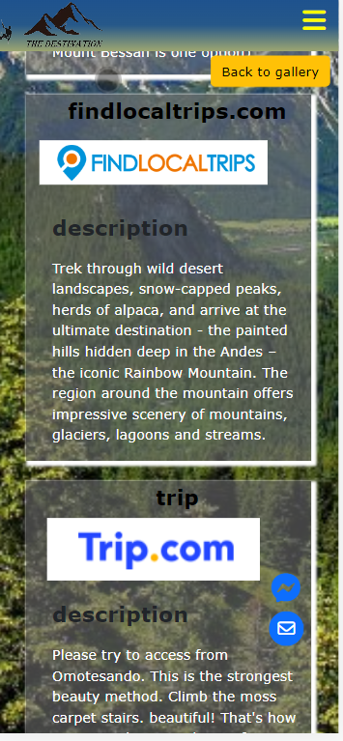

### 3. Organization

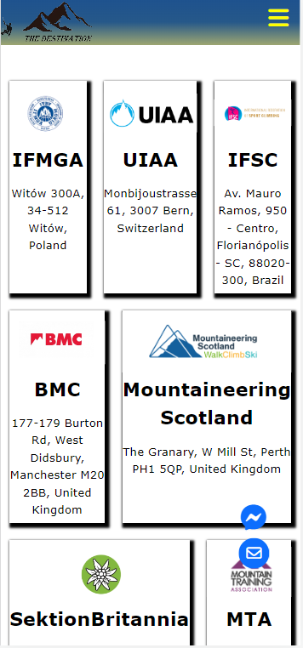 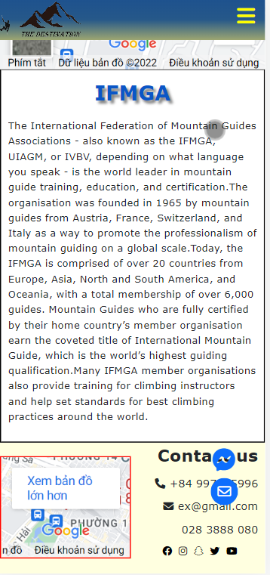

### 4. Information

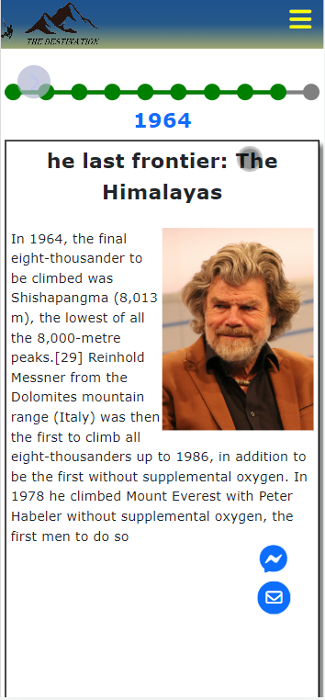 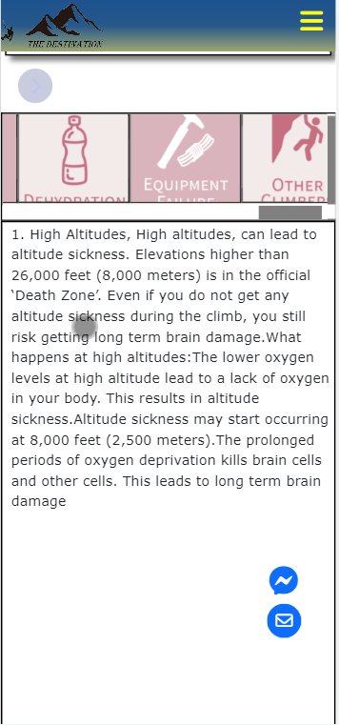

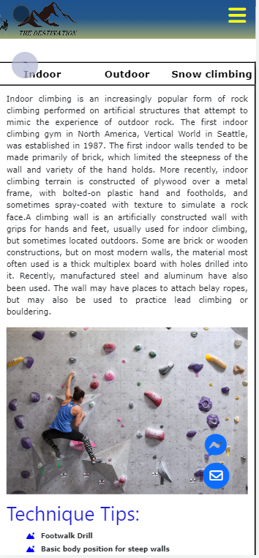 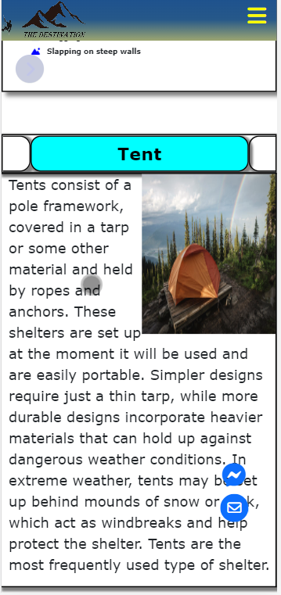

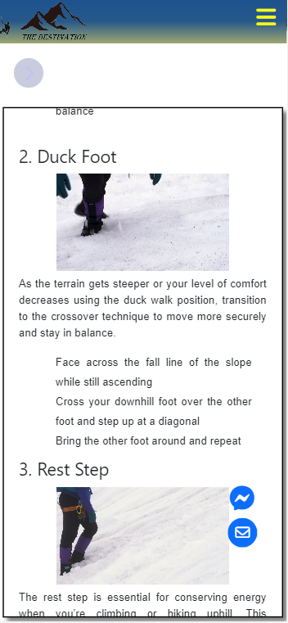

### 5. About us

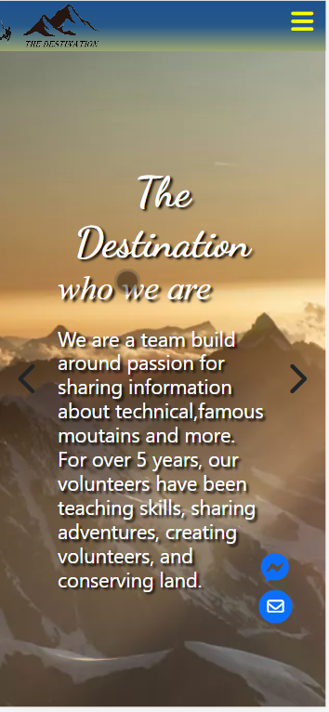 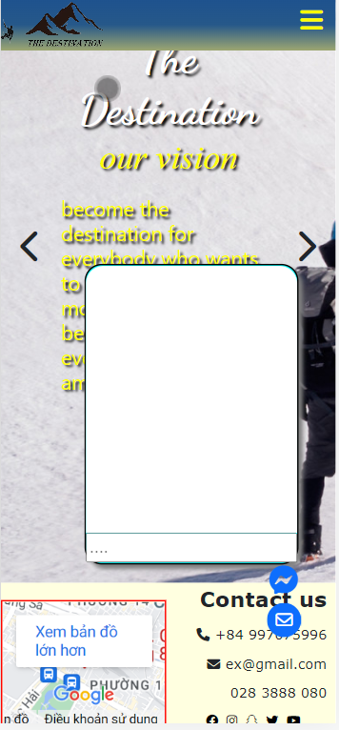

## Task Sheet

|  |  |  |  |  |
| --- | --- | --- | --- | --- |
| **TASK** | **Activity Plan Prepared by** | **Date of preparation of Activity Plan** | | |
| **Actual Start Date** | **Actual Days** | **Status** |
| Brainstorming ideas for layouts and Project Object | Dương, Minh, Thịnh,Sơn | 24/10/2022 | 3 days | 100% |
| Draw site maps and architecture design | Dương, Minh, Thịnh,Sơn | 27/10/2022 | 2 days | 100% |
| Wireframing general page layout | Dương, Minh, Thịnh,Sơn | 29/10/2022 | 2 days | 100% |
| Collect static assets (pictures, video, documentation,…) | Dương, Minh, Thịnh,Sơn | 31/10/2022 | 2 days | 100% |
| Design & Build Homepage, Website Layout | Dương | 2/11/2022 | 10 days | 100% |
| Design & Build Organization | Sơn | 2/11/2022 | 10 days | 100% |
| Design & Build History, Shelters, Hazards | Minh | 2/11/2022 | 10 days | 100% |
| Design & Build Style, Skills, Footer | Thịnh | 2/11/2022 | 10 days | 100% |
| Design & Build Message and Email Button | Dương | 12/11/2022 | 2 days | 100% |
| Design & Build About us | Thịnh | 12/11/2022 | 2 days | 100% |
| Collect more data for all sections | Sơn | 12/11/2022 | 2 days | 100% |
| Design & Build Mountain Tour | Minh | 12/11/2022 | 2 days | 100% |
| Product comparison, fix bug, redesign web layout | Dương, Thịnh, Minh,Sơn | 14/11/2022 | 5 days | 100% |
| Write Project Report | Thịnh | 19/11/2022 | 2 days | 100% |

## Testing Document

|  |  |  |  |  |
| --- | --- | --- | --- | --- |
| **No.** | **Features Tested** | | | **Remarks** |
| 1 | Are all the users able to view the images and links? | | | OK |
| 2 | Have all the views, modules and controllers been | |  | OK |
| properly integrated and is the site function as a single | | |
| page application? | |  |
| 3 | Are the GUI content devoid of spelling mistakes? | | | OK |
| 4 | Is the application user-friendly? | | | OK |
| 5 | Is the Website launching correctly in all popular | |  | OK |
| browsers? |  |  |
| 6 | Are all the forms validated with proper criteria? | | | OK |
| 7 | Do all text links lead to the appropriate website? | | | OK |
| 8 | Do all image links lead to the appropriate website? | | | OK |
| 9 | Are all the images and links clearly visible on the page? | | | OK |
| 10 | Does the Web page work properly in all the tested | |  | OK |
| browsers? |  |  |
| 11 | Does the Web page take too long to be loaded fully? | | | OK |
| 12 | Is the navigation sequences correct throughout sthe Web | | | OK |
| pages on the site? | |  |
| 13 | Is the JavaScript code working as expected in all click | | | OK |